Model Name
XC3 AIR Tech Gaming Chair

Pictures

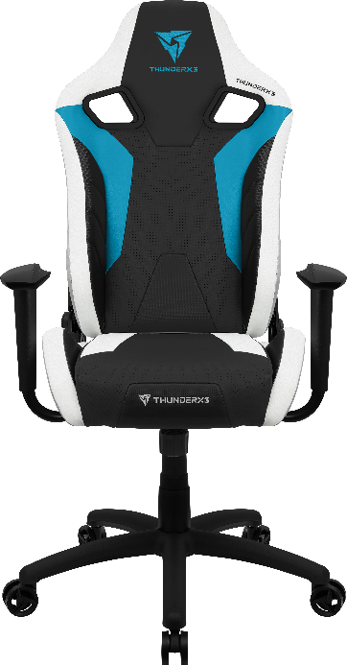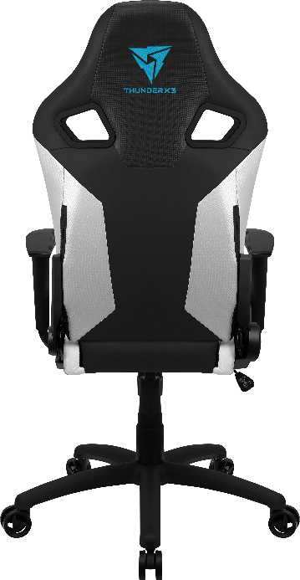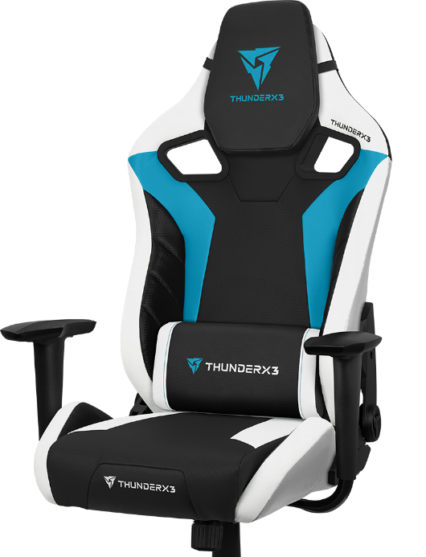

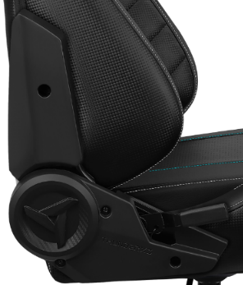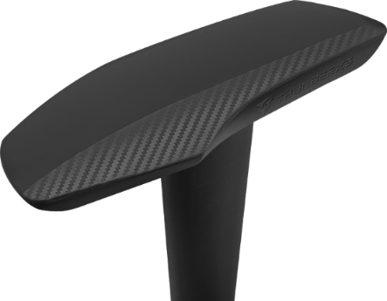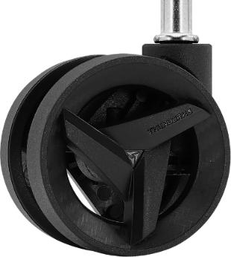

Features

All day comfort
- Premium leatherette with carbon pattern
- AIR Tech - Breathable pinhole surface
- High density foam for premium comfort
- Cushions for head and back
- Comfort PU armrest
Fully adjustable
- Tilt control mechanism
- Adjustable backrest
- Adjustable seat height
Built to last
- 350MM sturdy nylon base
- 65MM sturdy nylon caster
- BIFMA tested 100MM Class 4 gas-lift

Specifications

Model name | XC3
Maximum weight | <150kg/330lbs
Recommended weight | <125kg/275lbs
Foam type | High density foam
Frame type | Steel
Adjustable armrests | No
Adjustable backrest | Yes
Mechanism type | Tilt control mechanism, single lock
Rocking mechanism | Yes, 3° - 18°
Gas lift class & height | BIFMA tested level 4, max. 100mm
Base size & type | 350mm nylon base
Caster size & material | 65mm nylon caster
Cover material | Leatherette with carbon pattern
Chair height (A) | 123-133cm / 48.4-52.4in
Backrest width (B) | 55cm / 21.7in
Backrest length (C) | 81cm / 31.9in
Seat width (D) | 52cm / 20.5in
Seat depth (E) | 52cm / 20.5in
Seat thickness (F) | 13cm / 5.2in
Seat height to floor (G) | 47-57cm / 18.5-22.4in
Armrests width (H) | 66cm / 26in
Armrests height to floor (I) | 67-77cm / 26.4-30.3in
Base width (J) | 70cm / 27.6in
Product weight | 17.5kg/38.5lbs

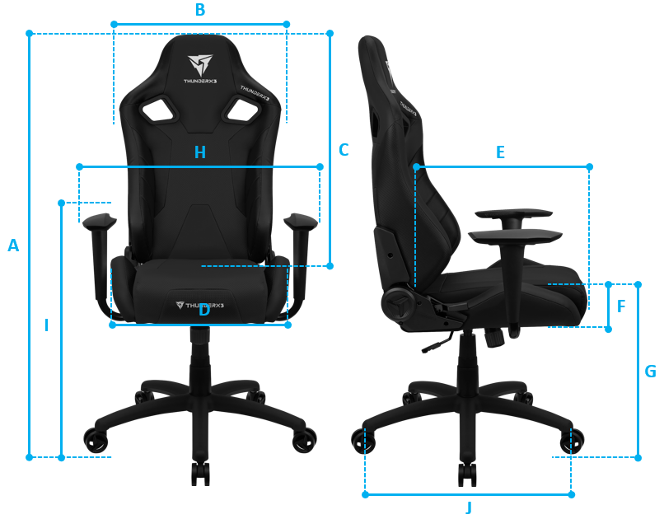
Shipping Information

Model Name | XC3
Color | EAN | UPC
Azure Blue | 4711099470648 | N/A
Neon Green | 4711099470655 | N/A
Bumblebee Yellow | 4711099470662 | N/A
Ember Red | 4711099470679 | N/A
All White | 4711099470686 | N/A
All Black | 4711099470693 | N/A
Carton Net Weight | 17.5 KGS
Carton Gross Weight | 21.5 KGS
Carton Size (L x W x H) | 84 x 68 x 33 CM
Carton Measure | 6.66 CUFT
20’ GP | 144 PCS
40’ HQ | 350 PCS

Warranty
1-year limited warranty

