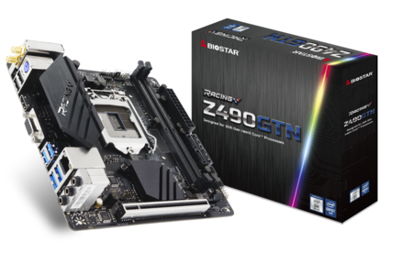 | Z490GTN 5.0  - Supports 10th Generation Intel Core™ Processor  - Intel Z490 single chip architecture  - Supports 2-DIMM DDR4- 2666/ 2800/ 2933 3200(OC)/3600(OC)/ 3800(OC)/ 4000(OC)/ 4400+(OC) up to 64 GB Memory  - Supports PCIe M.2 (32Gb/s)  - Supports Intel Optane Technology  - Supports HDMI 4K resolution  - Supports GbE LAN  - Supports WiFi 6 (No Wifi 6 card included)

Chipset | - Intel Z490
CPU SUPPORT | - Socket 1200 for 10th Gen Intel Core™, Pentium and Celeron processors  - * 10th Generation Intel Core™ Processor Family only support 400-Series.  - * Please refer to www.biostar.com.tw for CPU support list.
MEMORY | - Supports Dual Channel DDR4 2133/ 2400/ 2666/ 2800/ 2933  - Supports Dual Channel DDR4 3200(OC)/ 3600(OC)/ 3800(OC)/ 4000(OC)/ 4400+(OC)  - 2 x DDR4 DIMM Memory Slot, Max. Supports up to 64 GB Memory  - Each DIMM supports non-ECC 4/ 8/ 16/ 32GB DDR4 module  - * Please refer to www.biostar.com.tw for Memory support list.
INTEGRATED VIDEO | - By CPU model
STORAGE | - 4 x SATA III (6Gb/s) : Supports AHCI, RAID 0, 1, 5, 10 & Intel Rapid Storage Technology  - 1 x M.2 (M Key) Socket:  - Supports M.2 Type 2280 SSD module, NVMe & AHCI SSD  - Supports PCIe 3.0 x 4 (32Gb/s) & SATA III (6Gb/s) SSD  - Supports PCIe RAID 0, 1 & Intel Rapid Storage Technology, Intel Optane Technology
LAN | - Intel i219V  - 10/ 100/ 1000 Mb/s auto negotiation, Half / Full duplex capability
AUDIO CODEC | - ALC892  - 7.1 Channels, High Definition Audio, Hi-Fi(Front)
USB | - 6 x USB 3.2 (Gen1) ports (4 on rear I/Os and 2 via internal header)  - 4 x USB 2.0 ports (2 on rear I/Os and 2 via internal headers)
EXPANSION SLOT | - 1 x PCIe 3.0 x 16 Slot
REAR I/O | - 2 x WiFi Antenna Ports (Optional)  - 1 x PS/2 Keyboard/ Mouse  - 1 x HDMI Port  - 1 x VGA Port  - 1 x LAN Port  - 2 x USB 2.0 Ports  - 4 x USB 3.2(Gen1) Ports  - 3 x Audio Jack
INTERNAL I/O | - 4 x SATA III Connectors (6Gb/s)  - 1 x M.2 (E Key) Socket : Supports 2230 type WiFi & Bluetooth module and Intel CNVi  - 1 x USB 2.0 Header (each header supports 2 USB 2.0 ports)  - 1 x USB 3.2 (Gen1) Header (each header supports 2 USB 3.2 (Gen1) ports)  - 1 x 8-Pin Power Connector  - 1 x 24-Pin Power Connector  - 1 x CPU Fan Connector  - 1 x CPU water cooling connector (CPU_OPT)  - 1 x System Fan Connector  - 1 x Front Panel Header  - 1 x Front Audio Header  - 1 x Clear CMOS Header  - 1 x Internal Stereo Speaker Header  - 1 x LED Header (5V)  - 1 x LED Header (12V)  - * M.2 E Key wireless card is not provided.
DIMENSION | - Mini ITX Form Factor Dimension: 17cm x 17cm ( W x L )
OS SUPPORT | - Support Windows 10 (64bit)  - ※Biostar reserves the right to add or remove support for any OS with or without notice.
ACCESSORIES | - 4 x SATA Cable  - 1 x I/O Shield  - 1 x DVD Driver  - 1 x Quick Guide  - 1 x WiFi accessories
FEATURES | - BIO-Relife  - BIO-Flasher  - BIOSTAR Flash  - BIOS EZ Mode /Advanced Mode  - BullGuard  - RACING GT Utility  - Intel Optane technology  - LED Rock Zone (12V*1 / 5V*2)

Cooperatives

Apacer

Asgard

Bitspower

FSP

GeIL

G.SKILL

HyperX

RAZER CHROMA

SilverStone

T-Force

TT thermaltake

XigmaTek

Audio+

Hi-Fi

A combination of exclusive hardware &amp; software design including &quot;ground-isolation circuit design&quot;,&quot;an independent audio power&quot;, and &quot;a built=on-board amplifier&quot;, with all these hardware features gives you the best audio quality and performance. As for software, we offer you a free bundle utility &quot;Multi-Channel Calibration&quot; which normally you'll find in high level sound systems; this feature allows you to auto detect your location; with a user friendly interface, you can easily adjust the volume of every speakers to make a well balanced surround sound. And of course, the built-on-board amplifier always gives you a super powerful sound comparing to other motherboards.
HD Audio

Provides high quality sound with minimal loss of audio fidelity.
Hi-Fi Ground

BIOSTAR Hi-Fi Ground ( Golden Line ) is noise-blocking multi-layer PCB design to isolates analog audio signals from digital sources. Unique PCB layout is ideal for exceptional clarity and high fidelity sound.
Hi-Fi AMP

The built-in amplifier can drive major high-end headphones with over 100dB loads and offer wide band-width, low noise, high slew rate and low distortion audio source from front panel I/O. Gaming enthusiasts can enjoy a fuller range of dynamic sound with crisper details and less distortion.
Smart Ear

Smart EAR is a windows-based audio utility which allows you to easily adjust system volume. With its user-friendly GUI, you can also increase or decrease impedance setting (Low/High Gain) to optimize your headphone performance. You can easily enjoy high-quality and awesome sound.
Hi-Fi Cap

BIOSTAR motherboards come with high quality ‘Non-Polarized Electrolysis Electric audio capacitors’ for each audio channel circuit. The customized audio capacitors deliver low noise, low distortion, and wide bandwidth to achieve the highest sound resolution and sound expansion. The critical component will ensure the most realistic sound effects to gaming enthusiasts.

Video+

HDMI 4K2K

The new 4K2K resolution enables high-definition image display with four times the resolution of full HD ,4K2K display is faithfully express bright, highly detailed content that fills the entire screen with lifelike images. Connectivity with PCs via a single HDMI cable for displaying 4K2K data.
DX12

DirectX 12 introduces the next version of Direct3D, the graphics API at the heart of DirectX. Direct3D is one of the most critical pieces of a game or game engine, and we've redesigned it to be faster and more efficient than ever before. Direct3D 12 enables richer scenes, more objects, and full utilization of modern GPU hardware.
Integrated HDMI with HDCP

Onboard HDMI connector allows full video & audio support. It has industry-leading high definition video quality.

Speed+

Intel GbE LAN

Unlike ordinary LAN solution, Intel® GbE LAN offers fewer CPU resource consumption and more bandwidth stability. Thus, Intel® LAN is the best choice for performance seekers.
PCIe M.2  PCIe M.2 32Gb/s is the latest storage interface, it delivers the highest bandwidth and lower latency. It's 3 times faster compared with PCIe M.2 10Gb/s. | 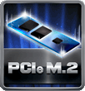
PCI-E Gen 3.0

PCI-E 3.0 is the next evolution of the ubiquitous and general-purpose PCI Express I/O standard. At 8GT/s bit rate, the interconnect performance bandwidth is doubled over PCI-E 2.0, while preserving compatibility with software and mechanical interfaces.
SATAIII 6Gbps

SATAIII 6Gbps provides a higher bandwidth to retrieve and transfer HD media. With this super speed data transfer, SATAIII allows an incredible data boost which is 2x faster than the SATA 3G.
Dual DDR4  The primary advantages of DDR4 over DDR3, include higher module density, lower voltage requirements, coupled with higher data transfer rate. | 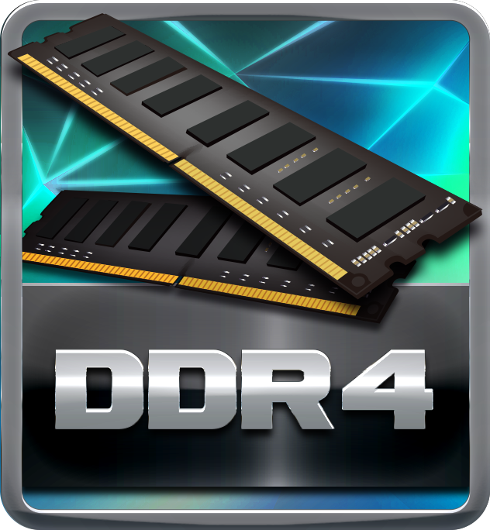
USB 3.2 Gen1 Type-A  USB 3.2 Gen1 delivers compelling performance boosts and can be used to connect multiple devices without worrying about compatibility. It is capable of data transfer speeds up to 5Gbps and backwards compatible with all existing USB products. | 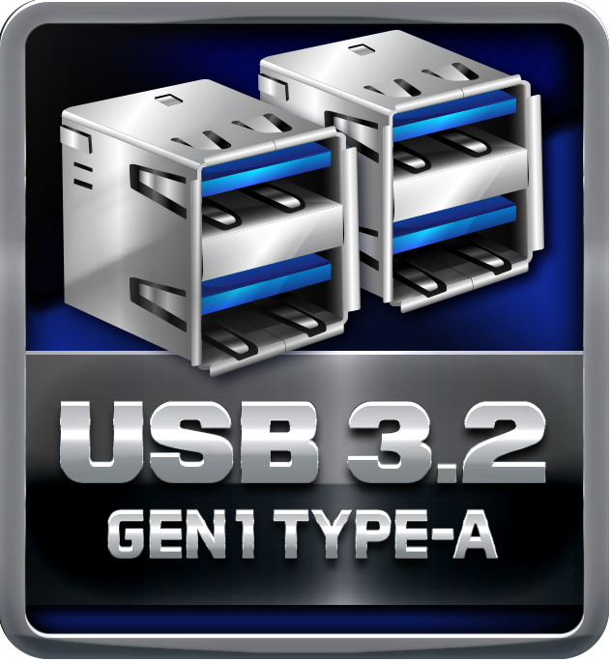
Intel Optane Memory Ready  Intel Optane memory can accelerate traditional storage devices to reduce boot times and improve the overall performance, like a brand-new system. This revolutionary memory technology transforms your old PC to a performance monster without expensive SSD. | 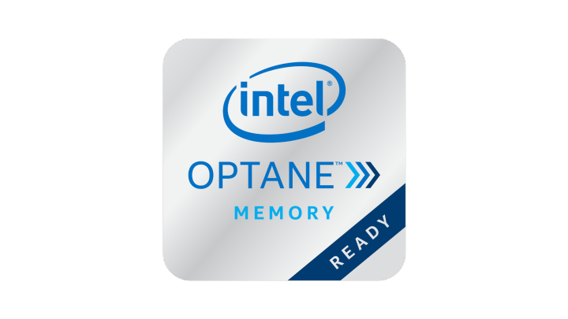

Durable+

Super Durable Solid Caps

The best quality solid state capacitors with ultra low ESR design, the Super Durable Solid Caps doubles the lifespan.
Moistureproof PCB

The popularity of PC usage and working environment is getting deteriorating and moist(rural, coastal, etc.). The PCB will be oxidizing easily by damp or absorbed moisture, and ionic migration or CAF (Conductive Anodic Filament) will be generated. Moisture-proof PCB meets high density and high reliability requirements for moisture proof.
Iron Slot Protection  The exclusive Iron Slot Protection can reinforce PCI-E x16 slots to handle heavier graphics cards, prevent bending, and extend longevity of the slot, making the new-gen RACING Series much more robust. | 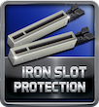
Tough Power Connectors  Tough Power Connectors are very robust that have larger area to ensure stable and reliable power supply. They can pack more power and durability to make your PC last longer. | 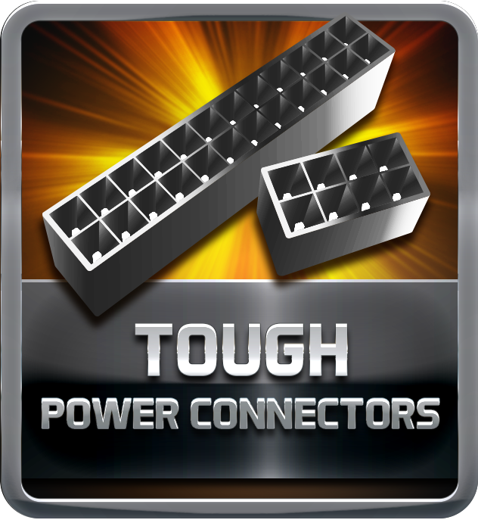
Super Durable Inductor

Super Durable Inductor brings the benefits of higher current capacity, lower energy loss and better power stability.
S-Hyper PWM  The S-Hyper PWM has DCR current sensing architecture and lossless characteristic, offering excellent precision in delivering stable power with 100% fixed voltage to ensure that critical components of the motherboard are under protected with the maximum performance and reliability. | 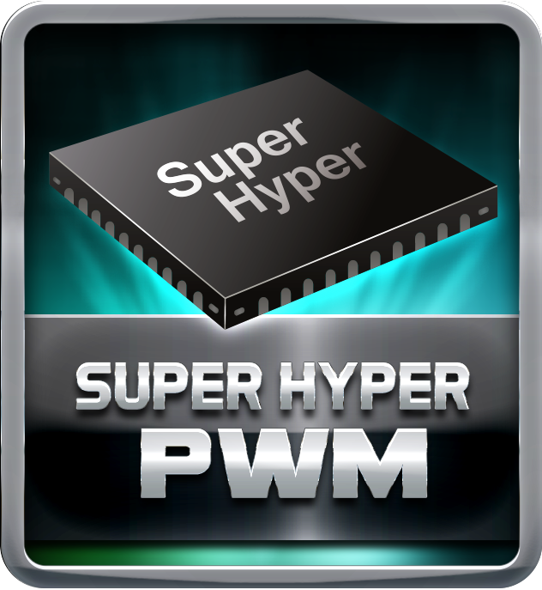

Protection+

Super LAN Surge Protection

Super LAN Surge Protection, providing LAN port with more advanced antistatic protection capabilities by adding an integrated chip to strengthen electrical stability and prevent damage from lightning strikes and electrical surges. SLSP (Super LAN Surge Protection) series motherboard upgrades the existing system protection standards with maximum 4X protection comparing to other board makers.
OC / OV / OH Protection

All BIOSTAR special circuit design detects overvoltage conditions and prevents voltage surges from spreading in real time. It also actively cuts off the overvoltage supply to protect your system. Over current protection, avoid motherboard from damage when doing overclock or an unusual current import. Over heat protection, avoid motherboard & CPU from burning when exceeding the temperature limitation.
BullGuard Internet Security (90 days FREE trial)

BullGuard Internet Security comes with the broadest line-up of internet security features on the market, including: a cutting-edge dual Antivirus engine, Online Backup for your precious files, PC Tune Up to speed up your system, a Game Mode for a seamless gaming experience, Parental Control, Firewall, Safe Browsing and many more. Make the most of your digital life with Bullguard!
Armor Gear

The new Armor Gear, which offers more stability and durability, comes with I/O Armor to protect I/O interfaces from static electricity. It is equipped with full-color RGB LED light that users can use VIVID LED DJ to synchronize it and build your own color gaming lights.

DIY+

Vivid LED DJ

New VIVID LED DJ with more customizability and options to control multiple RGB/ARGB LED lighting zones independently. Users can control color, speed and brightness for different modes at ease.
RACING UEFI BIOS

Unified Extensible Firmware Interface (UEFI) is a brand new framework that provides a revolutionary interface. It is a modern clear and easy-to-use graphical user interface. The UEFI comes with a colorful easy-understand icons leads users into the setup layer directly.
EZ Mode

BIOSTAR EZ Mode makes everything as simple and efficient as possible. It has an attractive easy-to-use BIOS system interface that guides users to solve their problems with ease. It lays out the things which you often do in BIOS system to make the flow smooth and seamless.
BIO-Flasher

Update BIOS effortlessly from a USB flash disk before entering the OS.
BIO-Flasher is a convenient BIOS update tool. Just launch this tool and put the BIOS on USB pen driver before entering the OS. You can update your BIOS with only a few clicks without preparing an additional floppy disk or other complicated flash utility.
A.I FAN

With A.I FAN users can ensure that their gaming PC can maintain its performance while staying cool. According to different cooling needs and usage scenarios, users can control speed modes. Allows users to have more customizability of fan modes and automatically detects different temperatures to make fan operate at defined speed for optimal cooling performance. Furthermore, A.I FAN support both PWM and DC voltage fans for more cooling options.
LED ROCK ZONE  LED ROCK ZONE comes with the RGB 12V LED header and Digital 5V LED header which offer more colorful lighting options to DIY lovers. Adjusting the color of LED and changing system colors by VIVID LED DJ will make you fully enjoy the process of PC modding developing your personal style. | 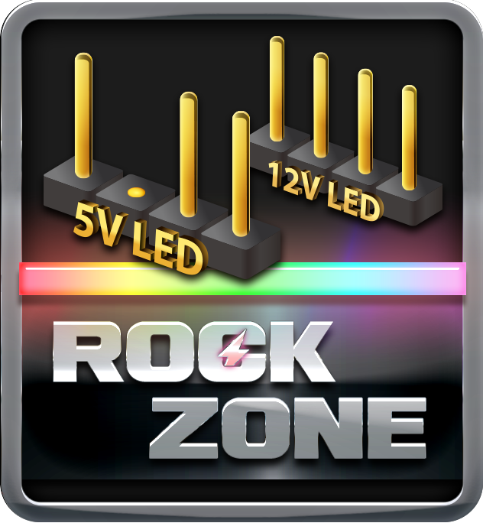
CPU OPT

BIOSTAR offers one more fan header which is called CPU OPT. Users can use it to connect any kind of water coolers for a liquid cooling system. Keep your computer stable and enjoy your machine at the utmost potential.

CPU-Chipset Features

Intel Z490 chipset  With the Intel&reg; Z490 chipset and the 10th generation Intel&reg; Core&trade; processors, you will immediately be at the forefront of the battlefield, fueled by mind-blowing power and performance. From content creation to gaming, the Intel Z490 chipset provides you with the power and performance you need. | 